DataFlow provides an effective execution mecanism for **Apache Beam**

**You Can use Dataflow for ETL.**

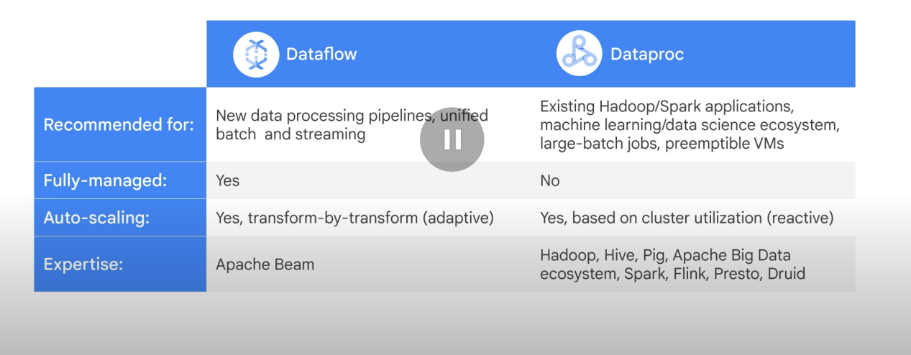

Dataflow is better than dataproc. You would only use dataproc if you have an exisiting project in Hadoop.

Dataflow allows you to use the same code for both batch and streaming (real-time) data processing.

Dataflow is serverless: no need to manage clusters manually.

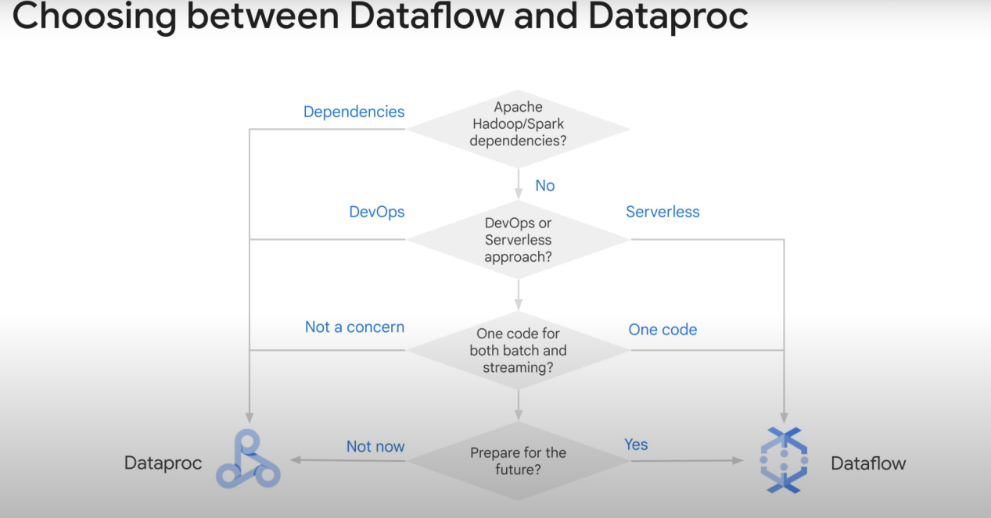

The Beam Pipeline (of apache beam) precises what needs to be done

VS

Dataflow chooses how to run the pipeline.

The pipeline contain steps like reading data, transforming it, and writing it.

**Dataflow will optimize everything** (E.g: merge transformations together, breaking a job into units of work and schedule each unit to workers, auto-scale everything, dynamic work rebalance, etc...) 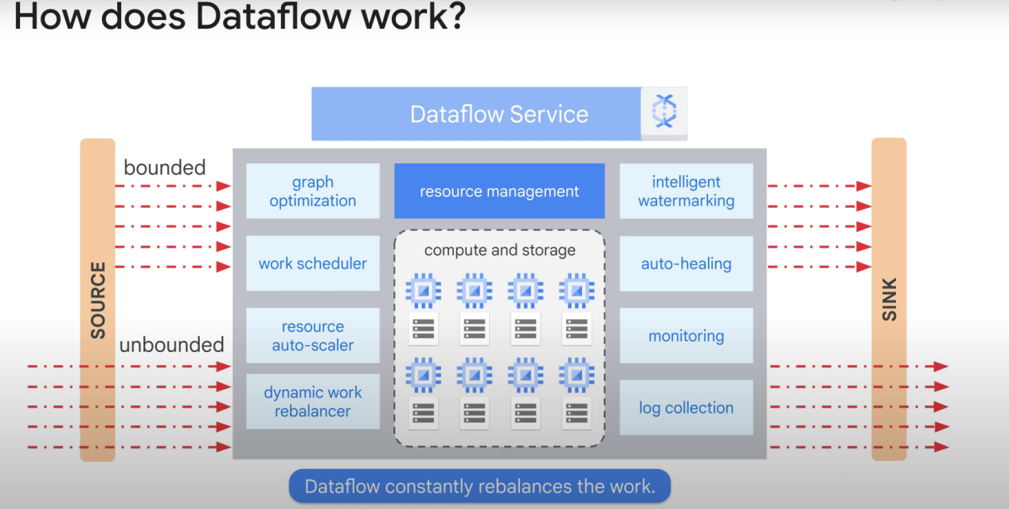

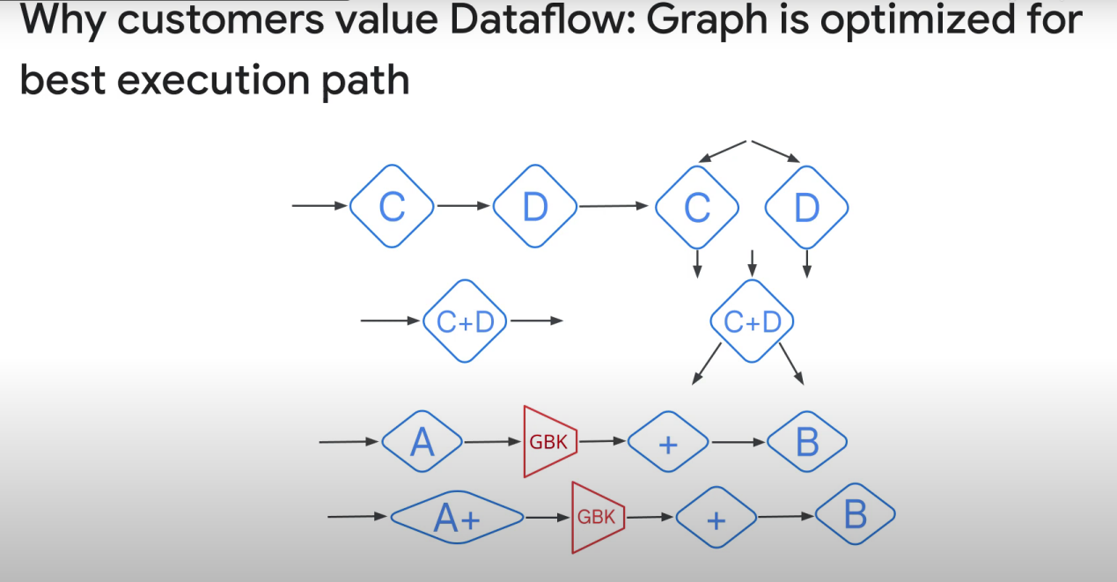

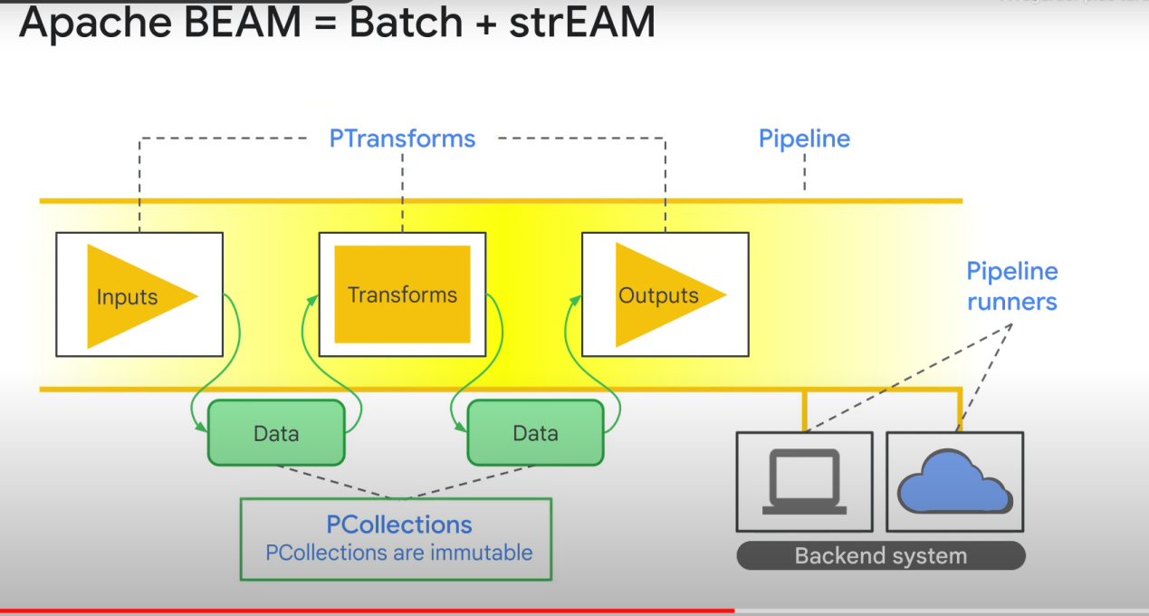

DATA IS IMMUTABLE! WE CREATE A NEW COLLETION AFTER EACH PTRANSFORM. WE DO NOT CHANGE THE ORIGINAL COLLECTION.

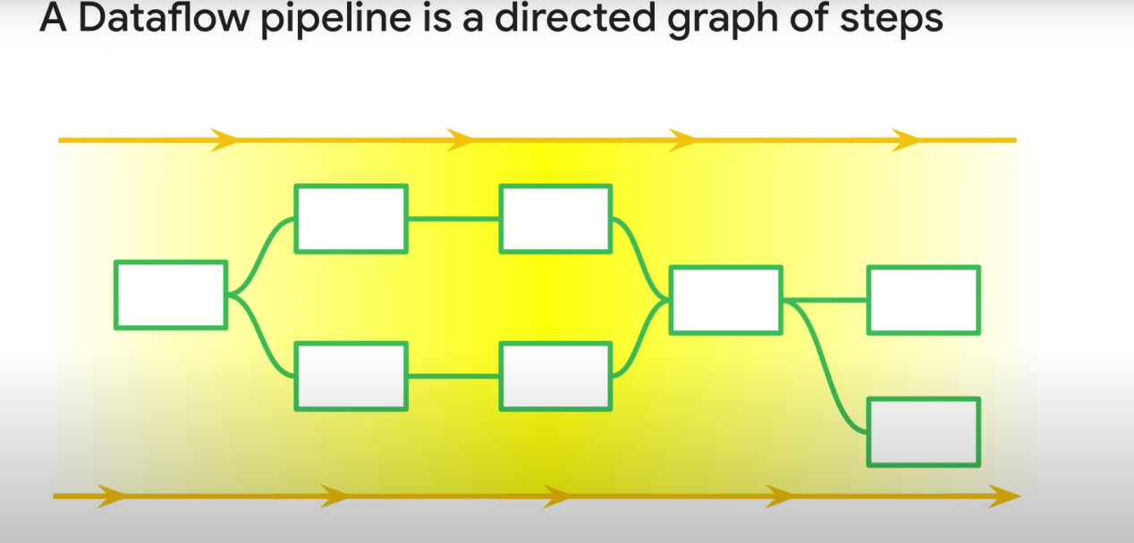

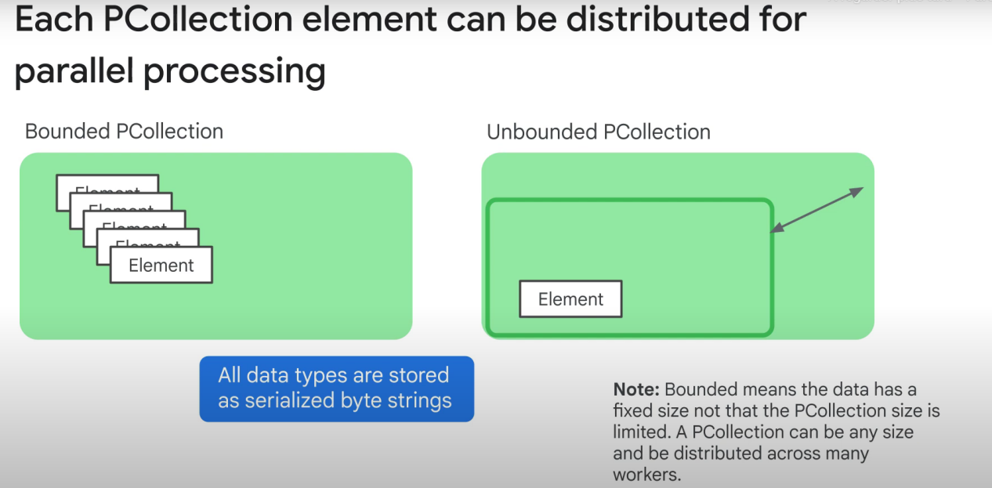

All elements from PCollections are stored as serialized byte strings. We only need to deserialize them when doing PTransforms. When sending the data via network, this saves us time as we don’t need to serialize them before sending them.